

**TUNKU ABDUL RAHMAN UNIVERSITY COLLEGE**

FACULTY OF COMPUTING AND INFORMATION TECHNOLOGY

BAIT2133 WEB ENGINEERING

PRACTICAL 5

1. Draw a class diagram based on the description as described below:

|  |
| --- |
| *A software training program is identified by a code and has a short description that explains its goals. Each software training program is divided into modules, and each module is described by module name and the appropriate practice time. Each module sometimes has prerequisite modules.* |

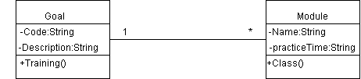

1. Redraw the following class diagram by adding the given details:

* All the attributes are private visible and all methods are public visible.
* In Customer class, set the name attribute to text type, age attribute to integer type. The method printDetails() just displays the attributes’ values.
* In Item class, set the id attribute to integer type, and price attribute to store double-precision, floating-point number. The method checkPrice() returns the price of the item, and method displayItem() displays the id and price.

purchase ►

Item

-id:int

-price:double

+checkPrice():bool

+displayItem():bool

Customer

-name:string

-age:int

+printDetails()

1. Draw a class diagram of the course registration system of your university. Identify items, attributes in the models. Shows the relationship between classes.

